**Pyspark_Assignment_Task1_Anup_Patil  
Covid Ananlysis**  
  
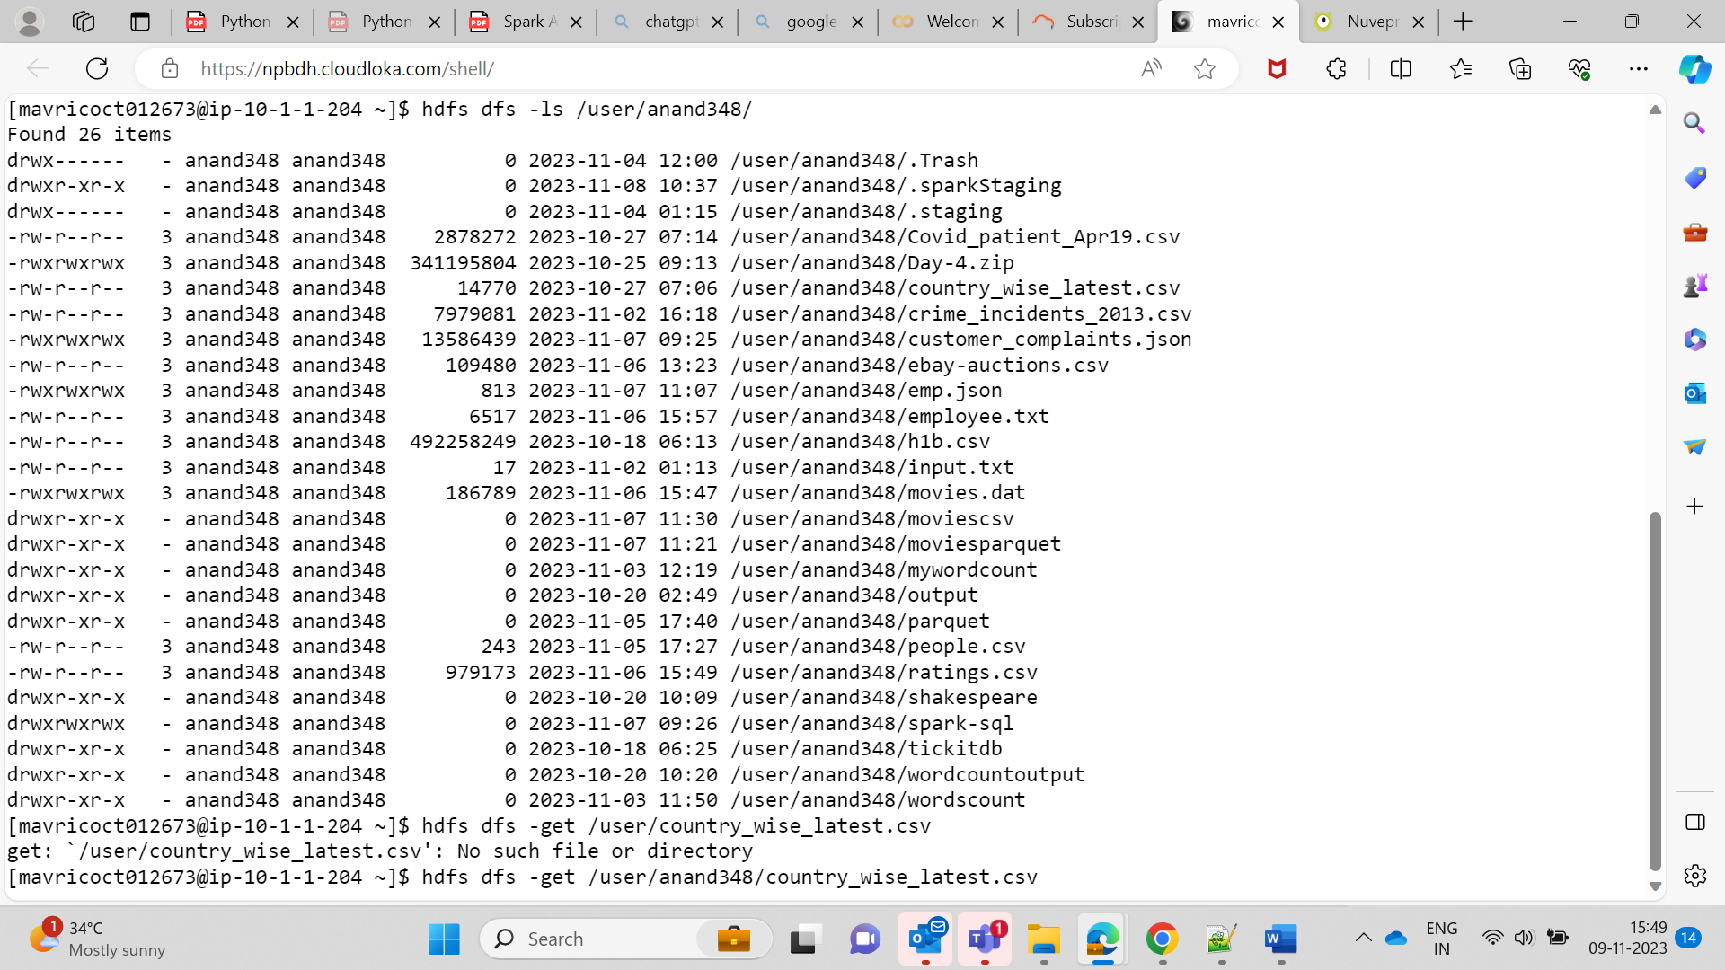  
  
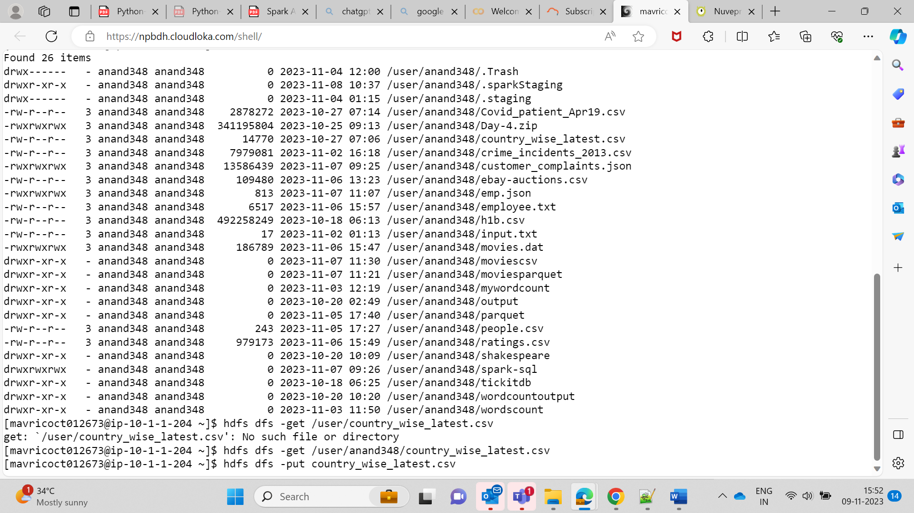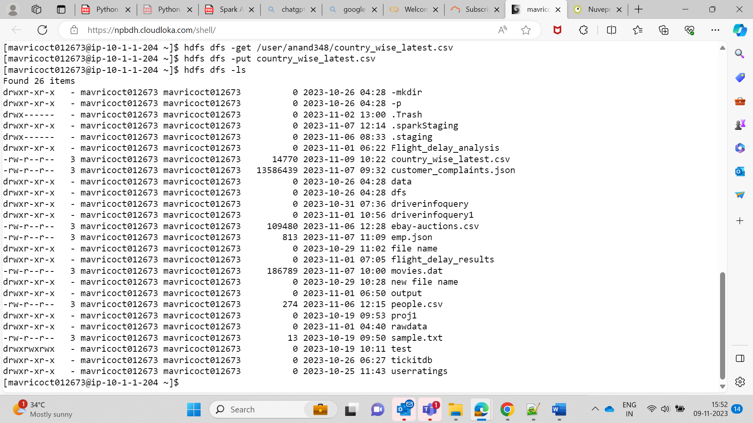

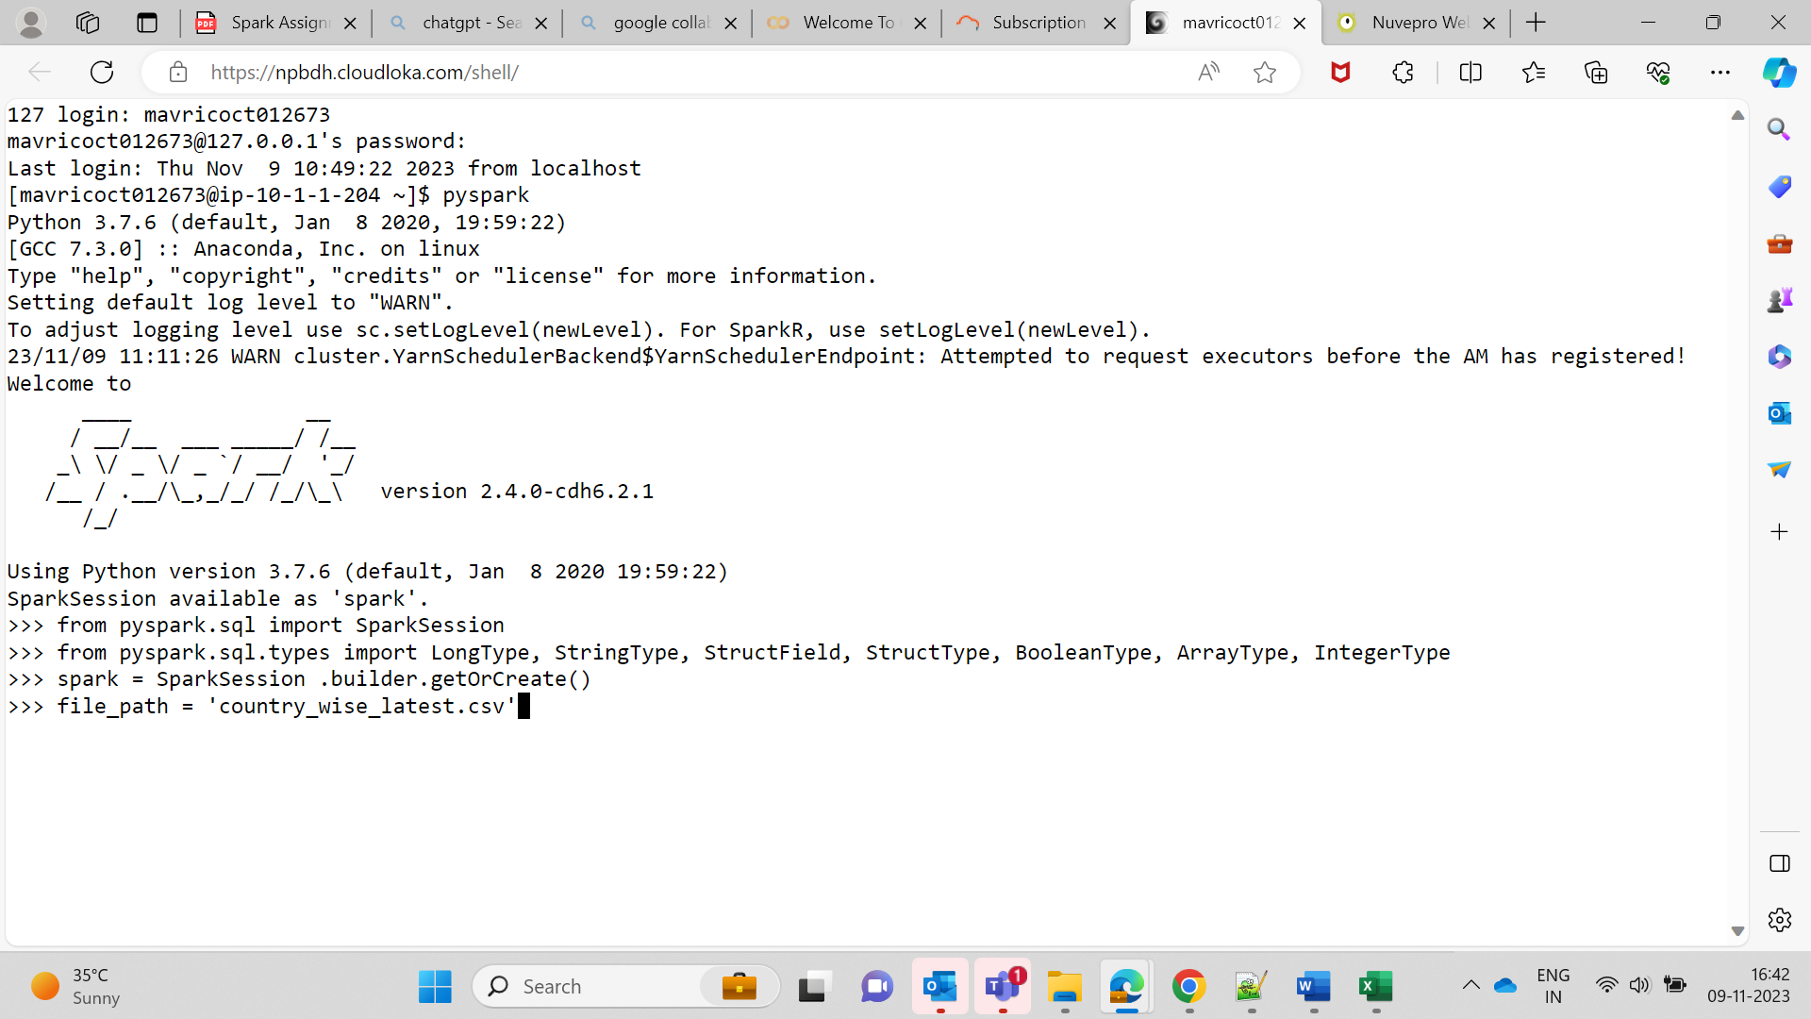  
  
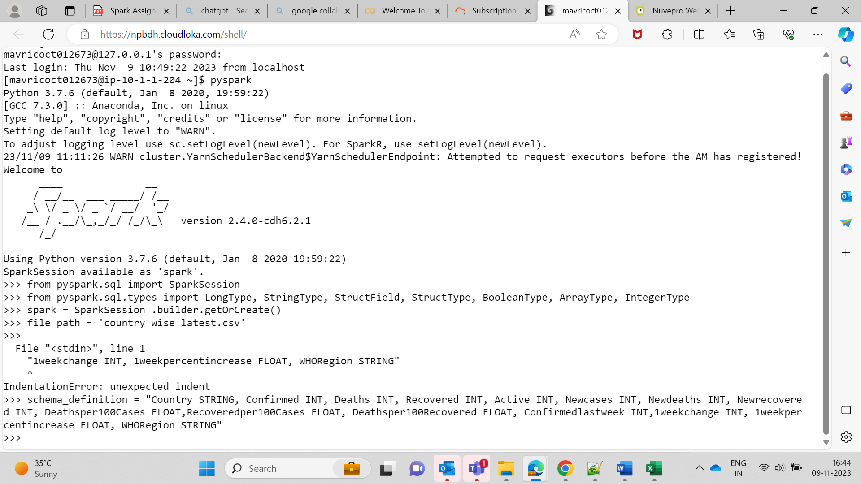  
  
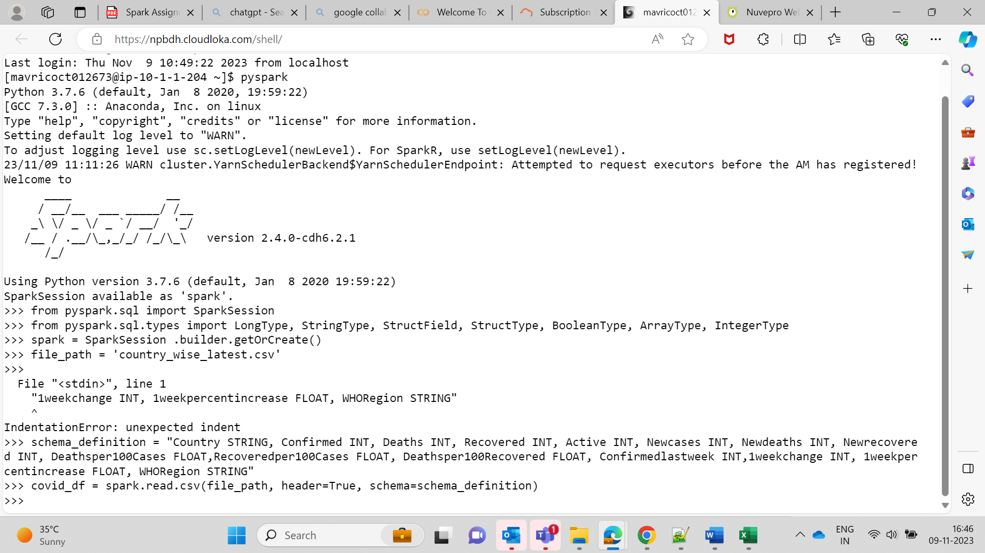  
  
  
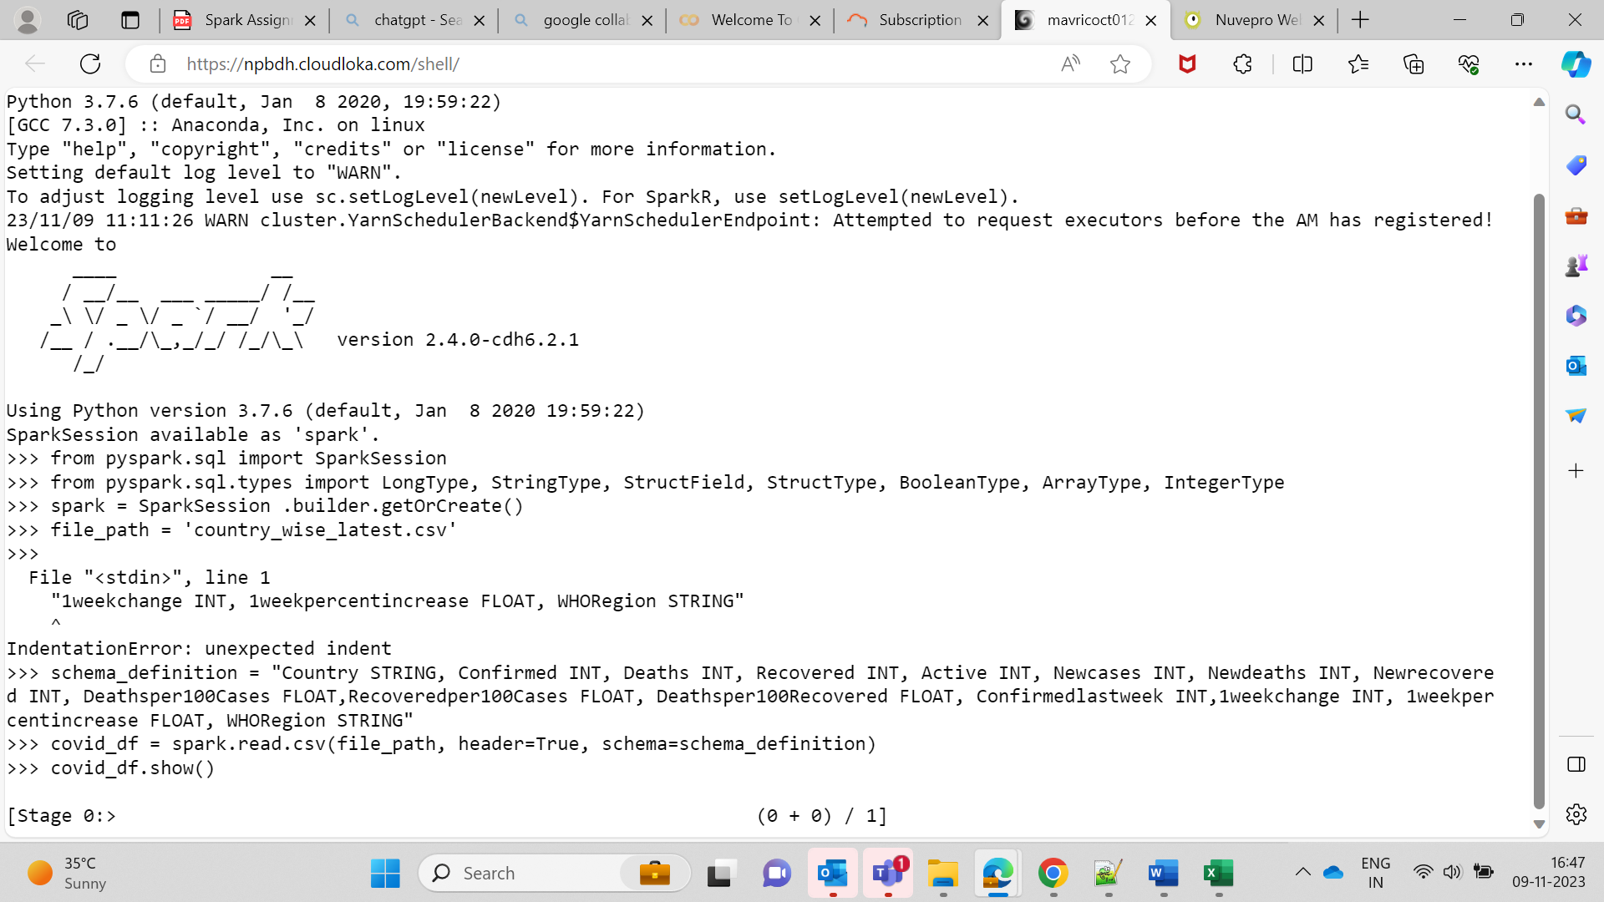  
  
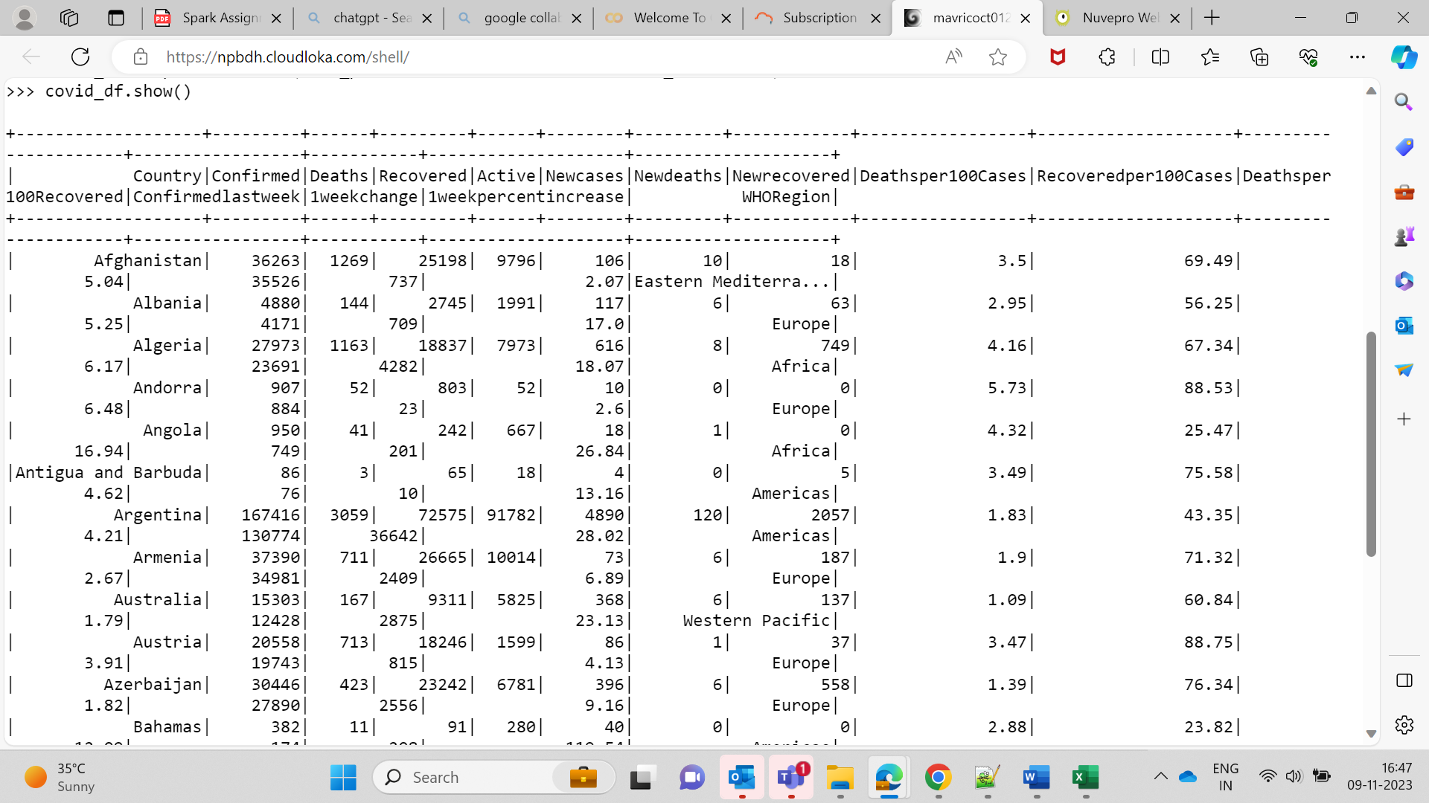  
  
  
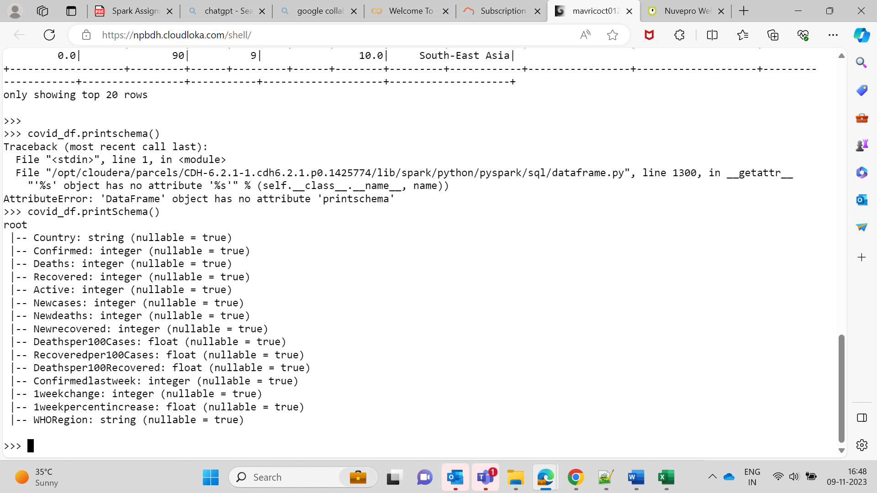  
  
  
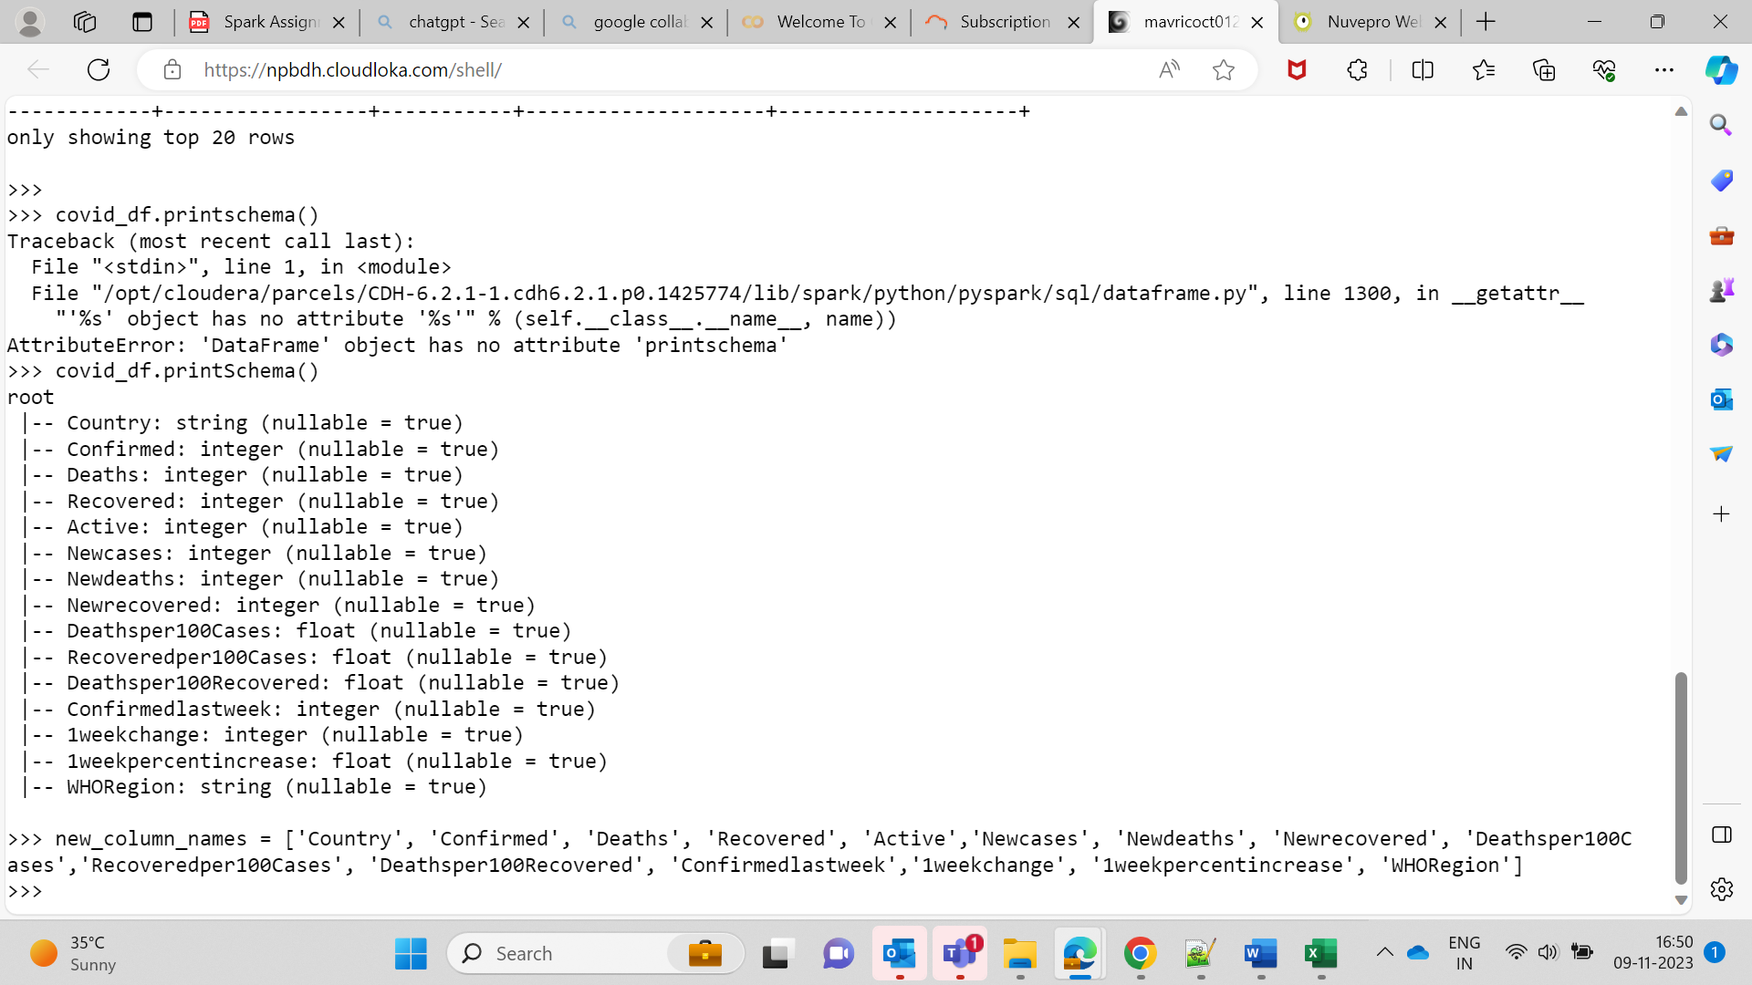  
  
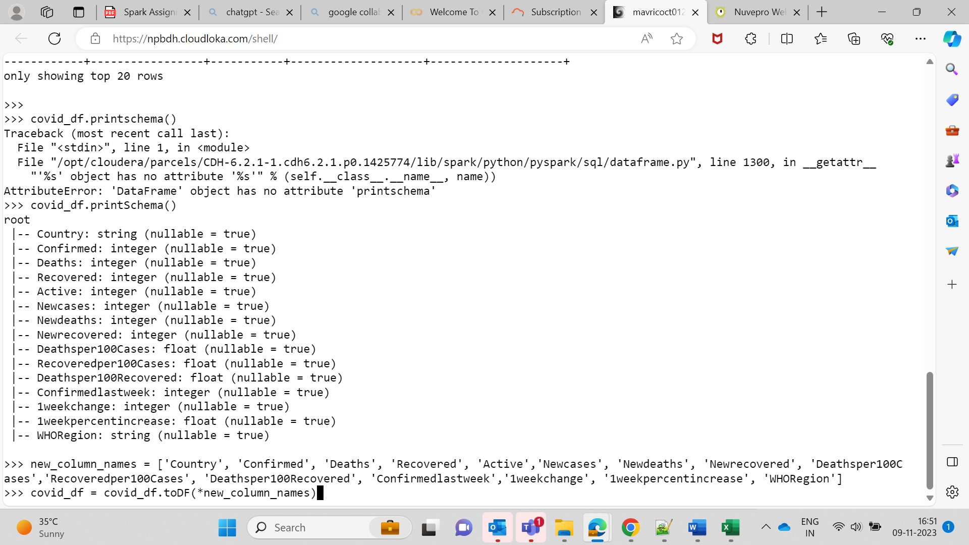

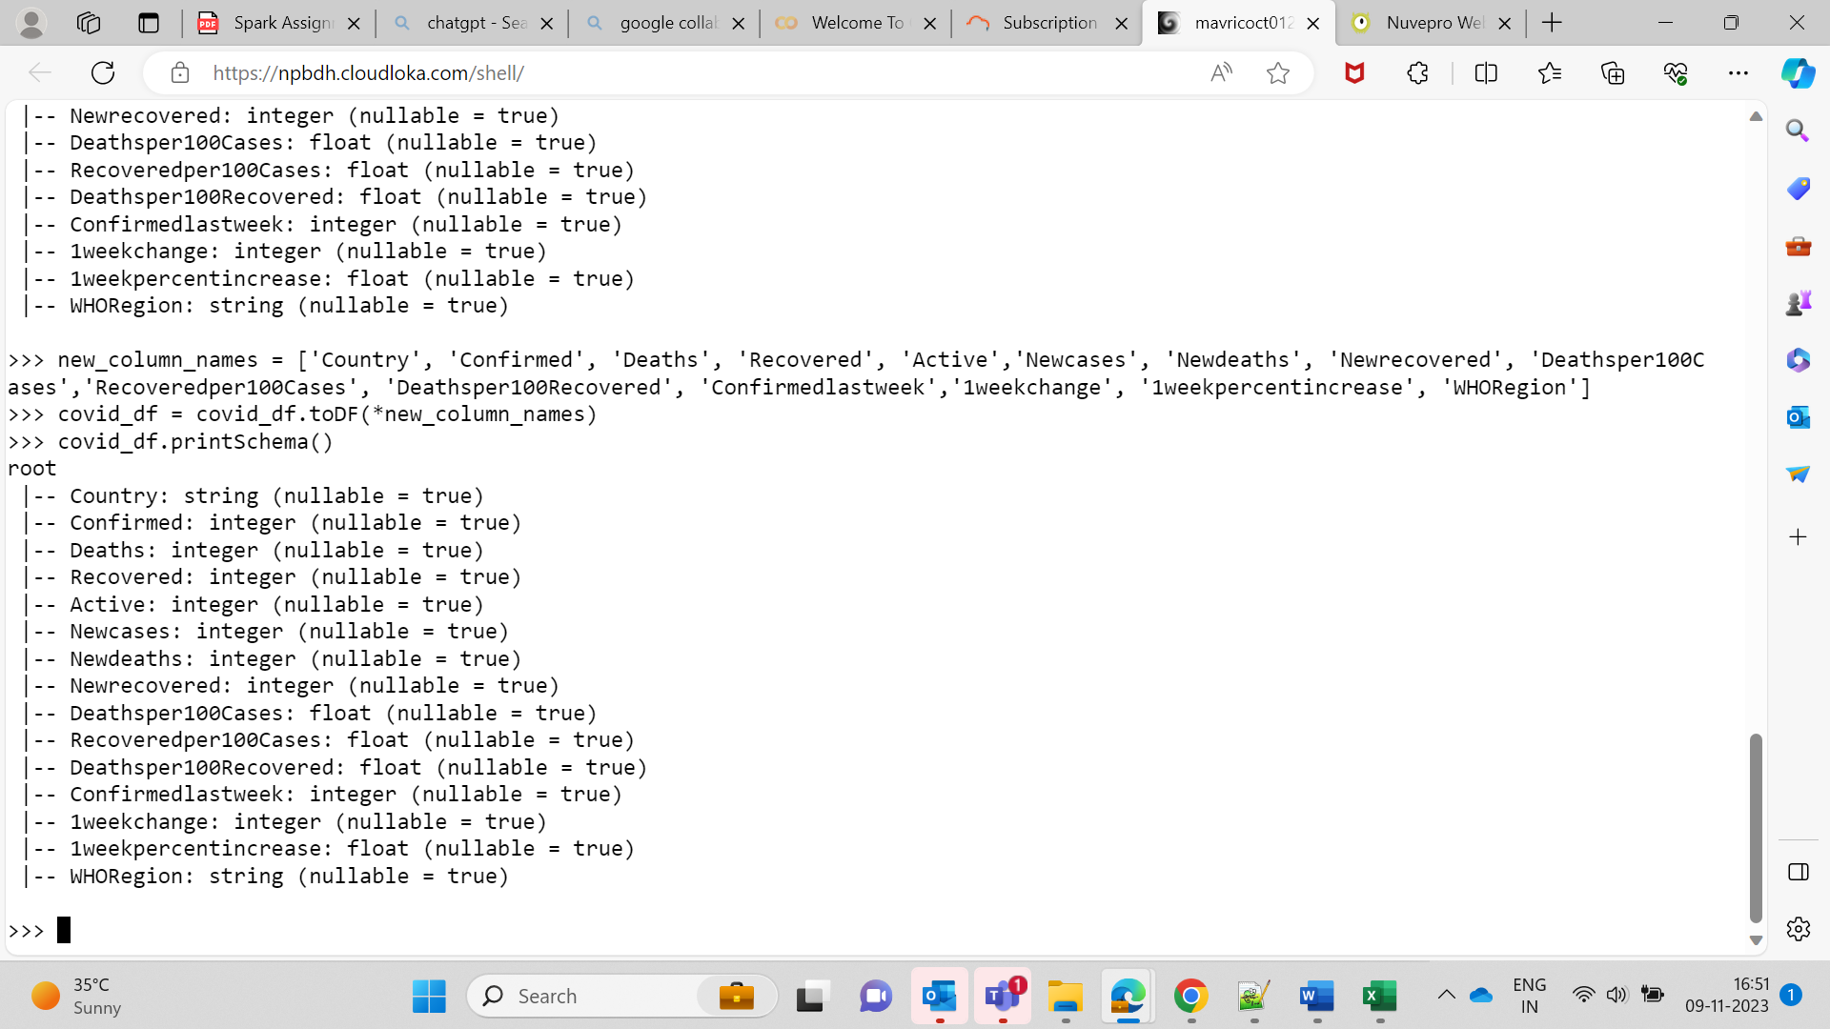  
  
  
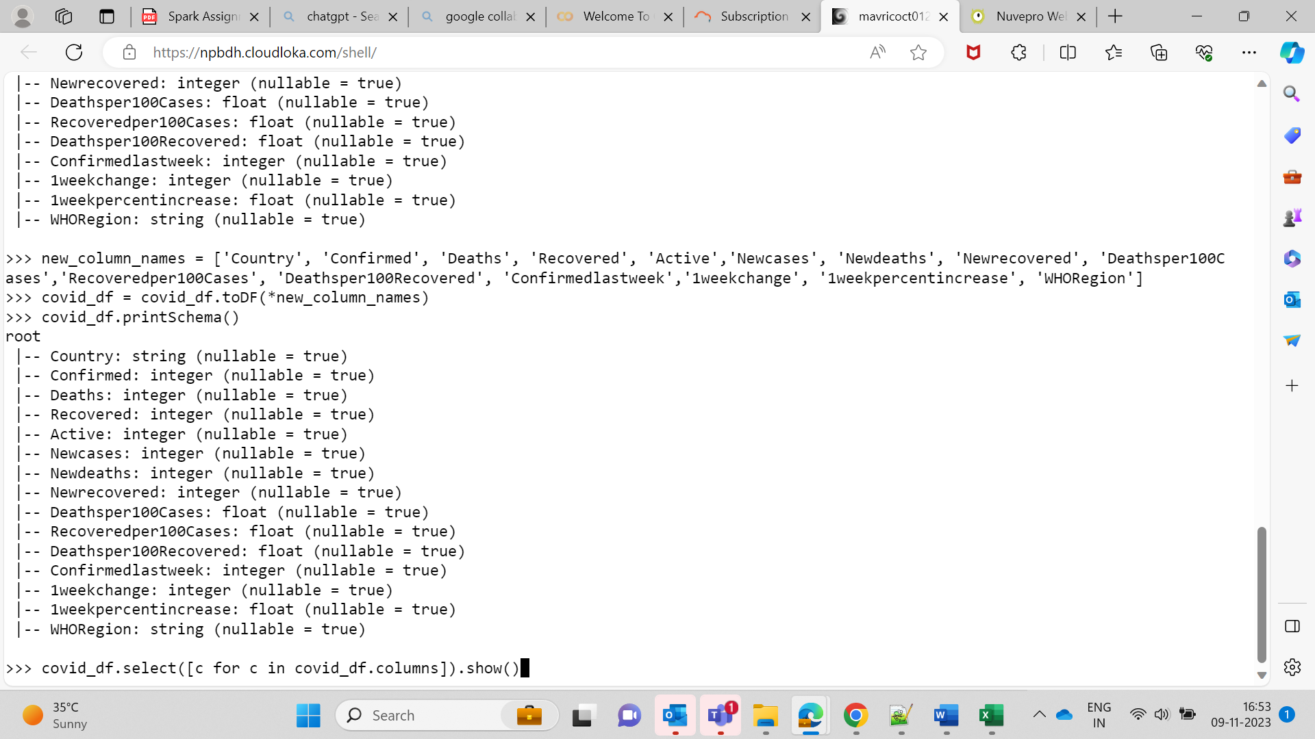  
  
Query1.  
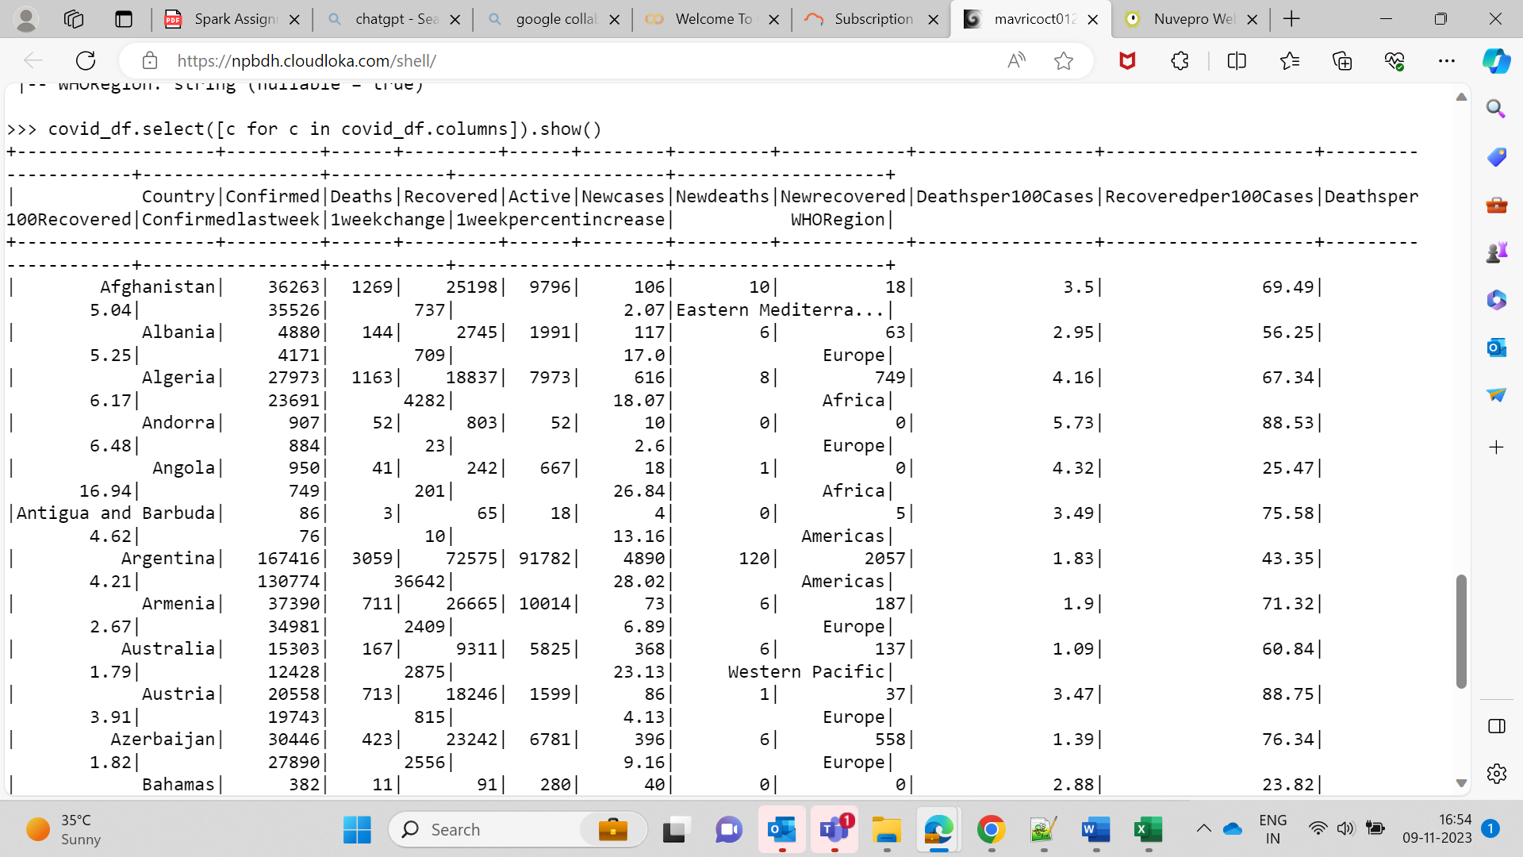

covid_df.describe().show()  
  
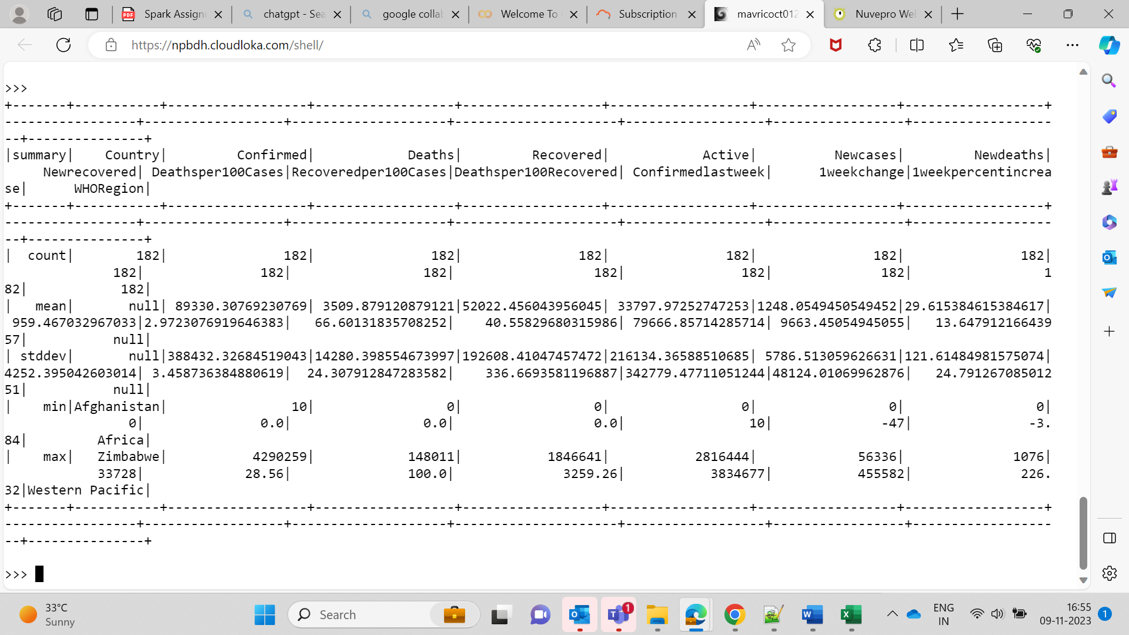  
  
**Query2  
Top 10 countries under the WHO region with COVID-19 confirmed cases**  
  
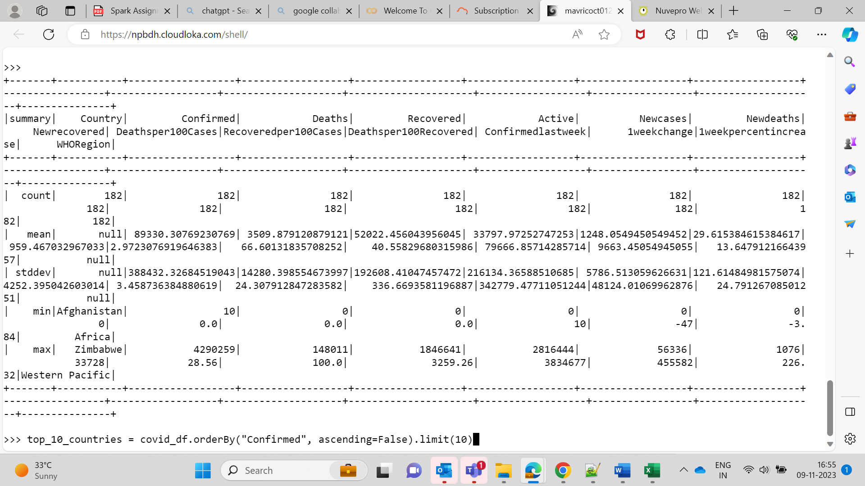  
  
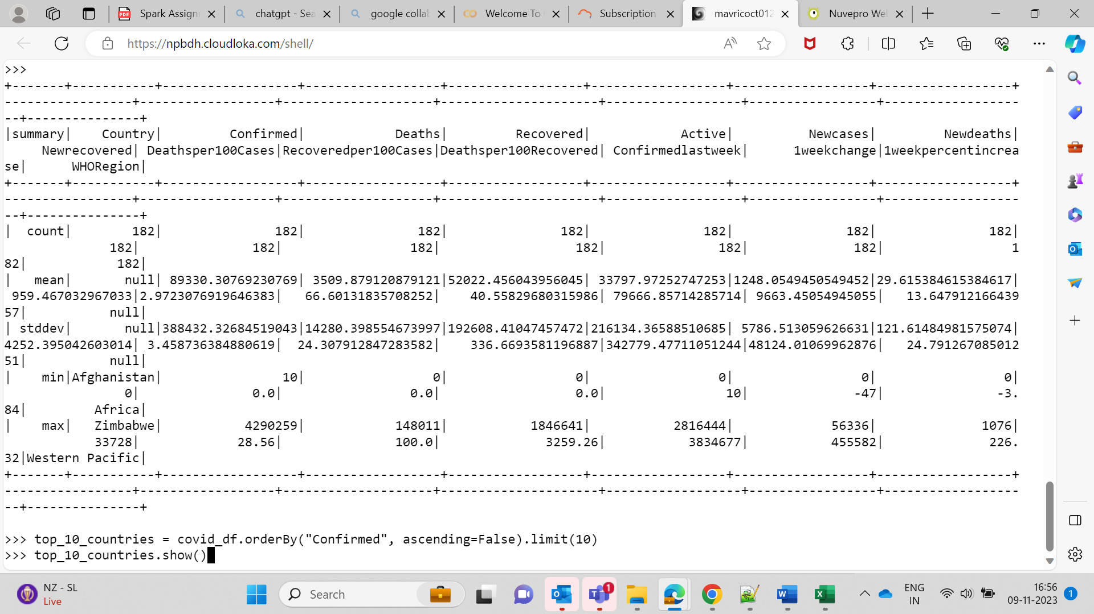  
  
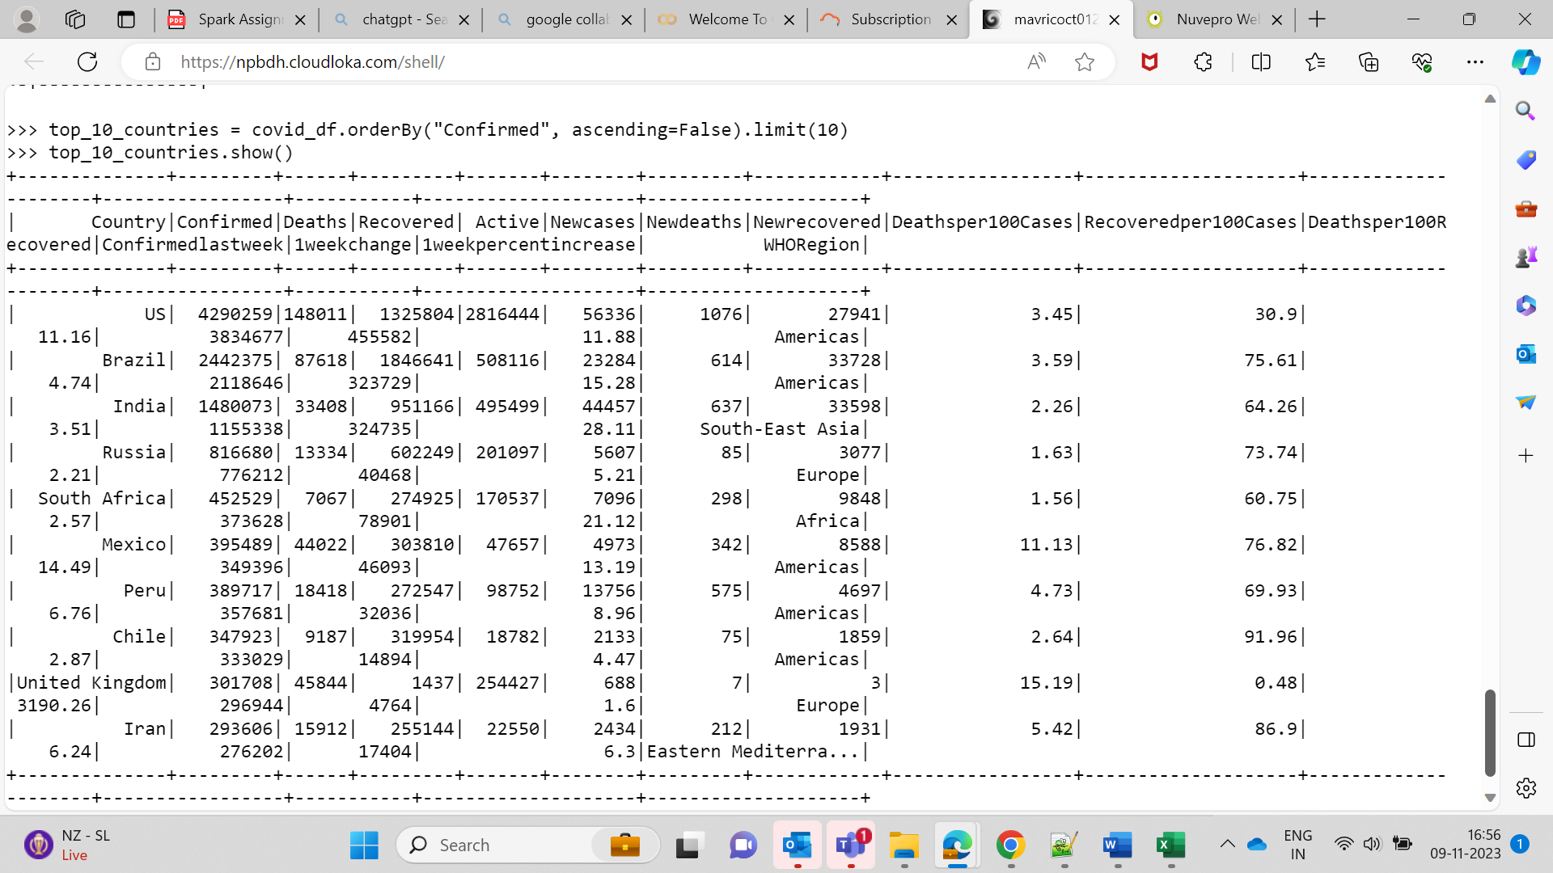  
  
top_10_countries = covid_df.orderBy("Confirmed", ascending=False).limit(10)

top_10_countries.show()  
  
**Q3. Total number of countries, total number of WHO regions, and list of WHO regions**

**total_countries = covid_df.select("Country").distinct().count()**

**total_who_regions = covid_df.select("WHORegion").distinct().count()**

**who_regions_list = covid_df.select("WHORegion").distinct().rdd.flatMap(lambda x: x).collect()**  
  
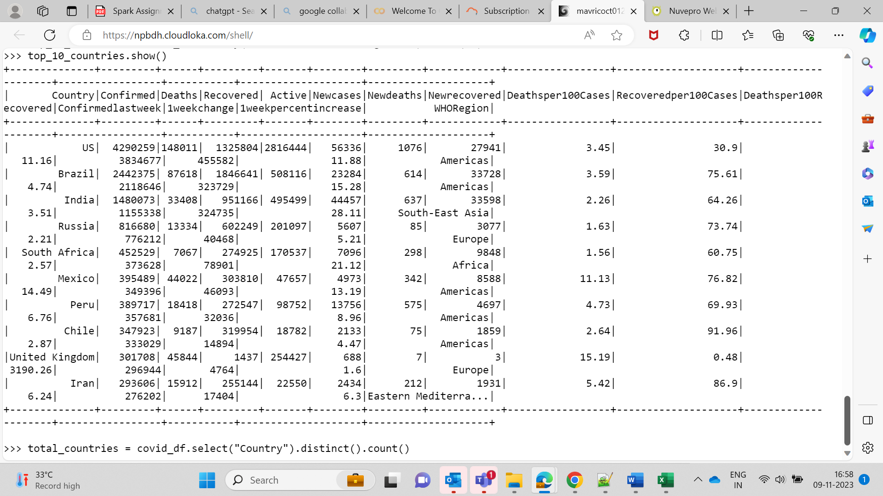  
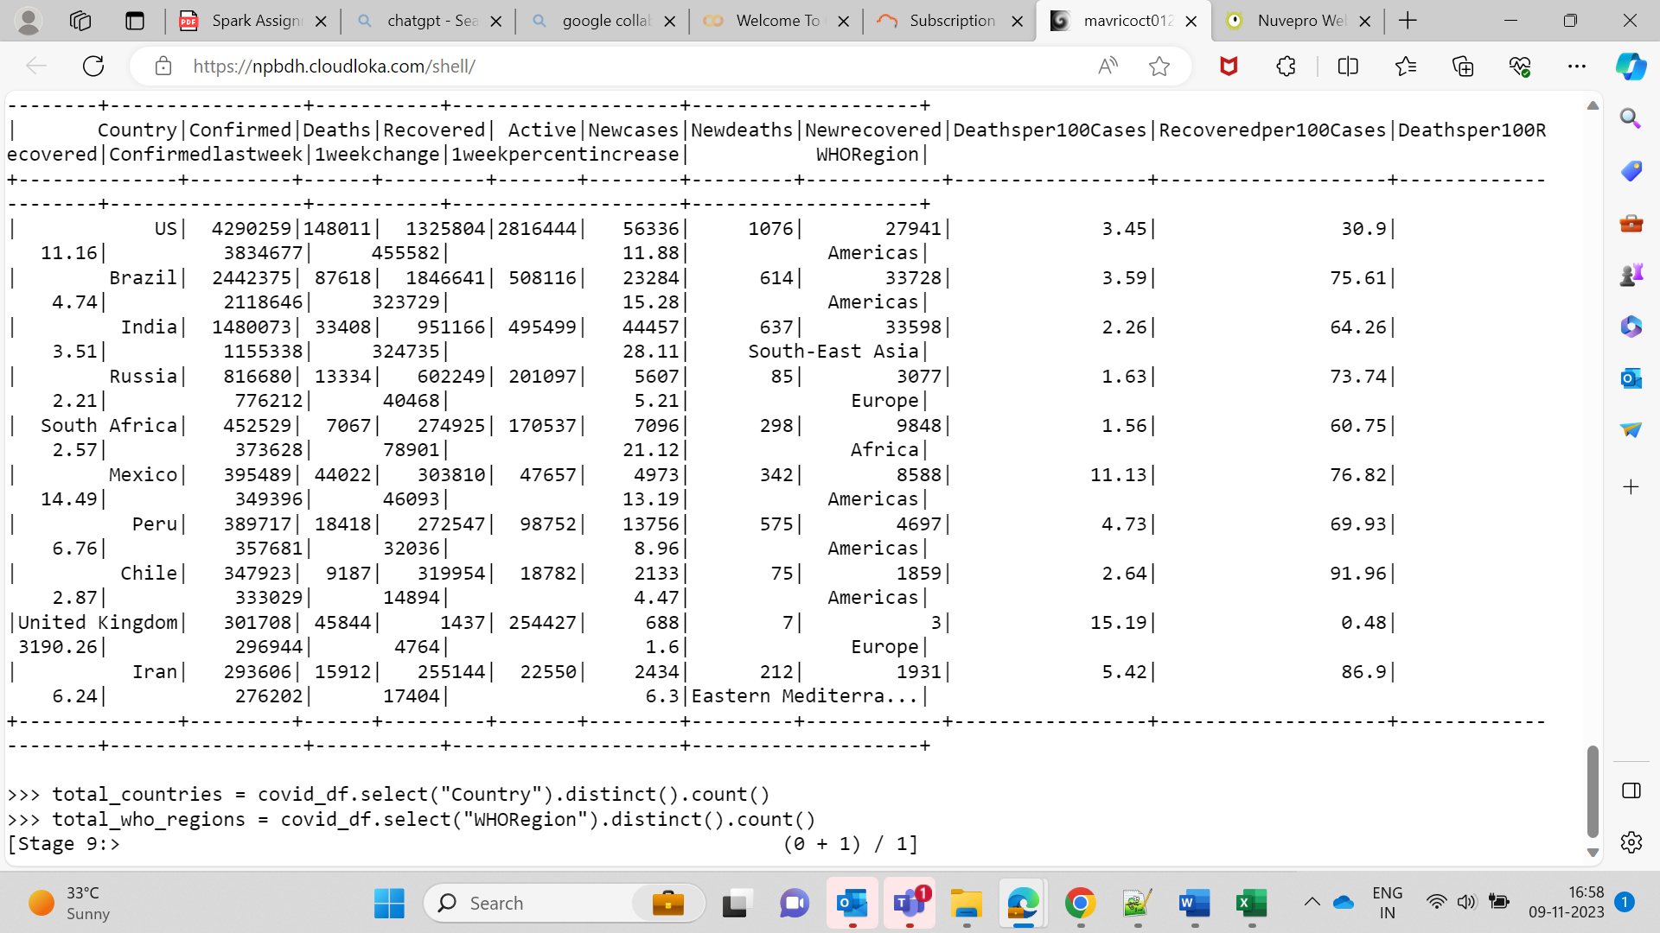  
  
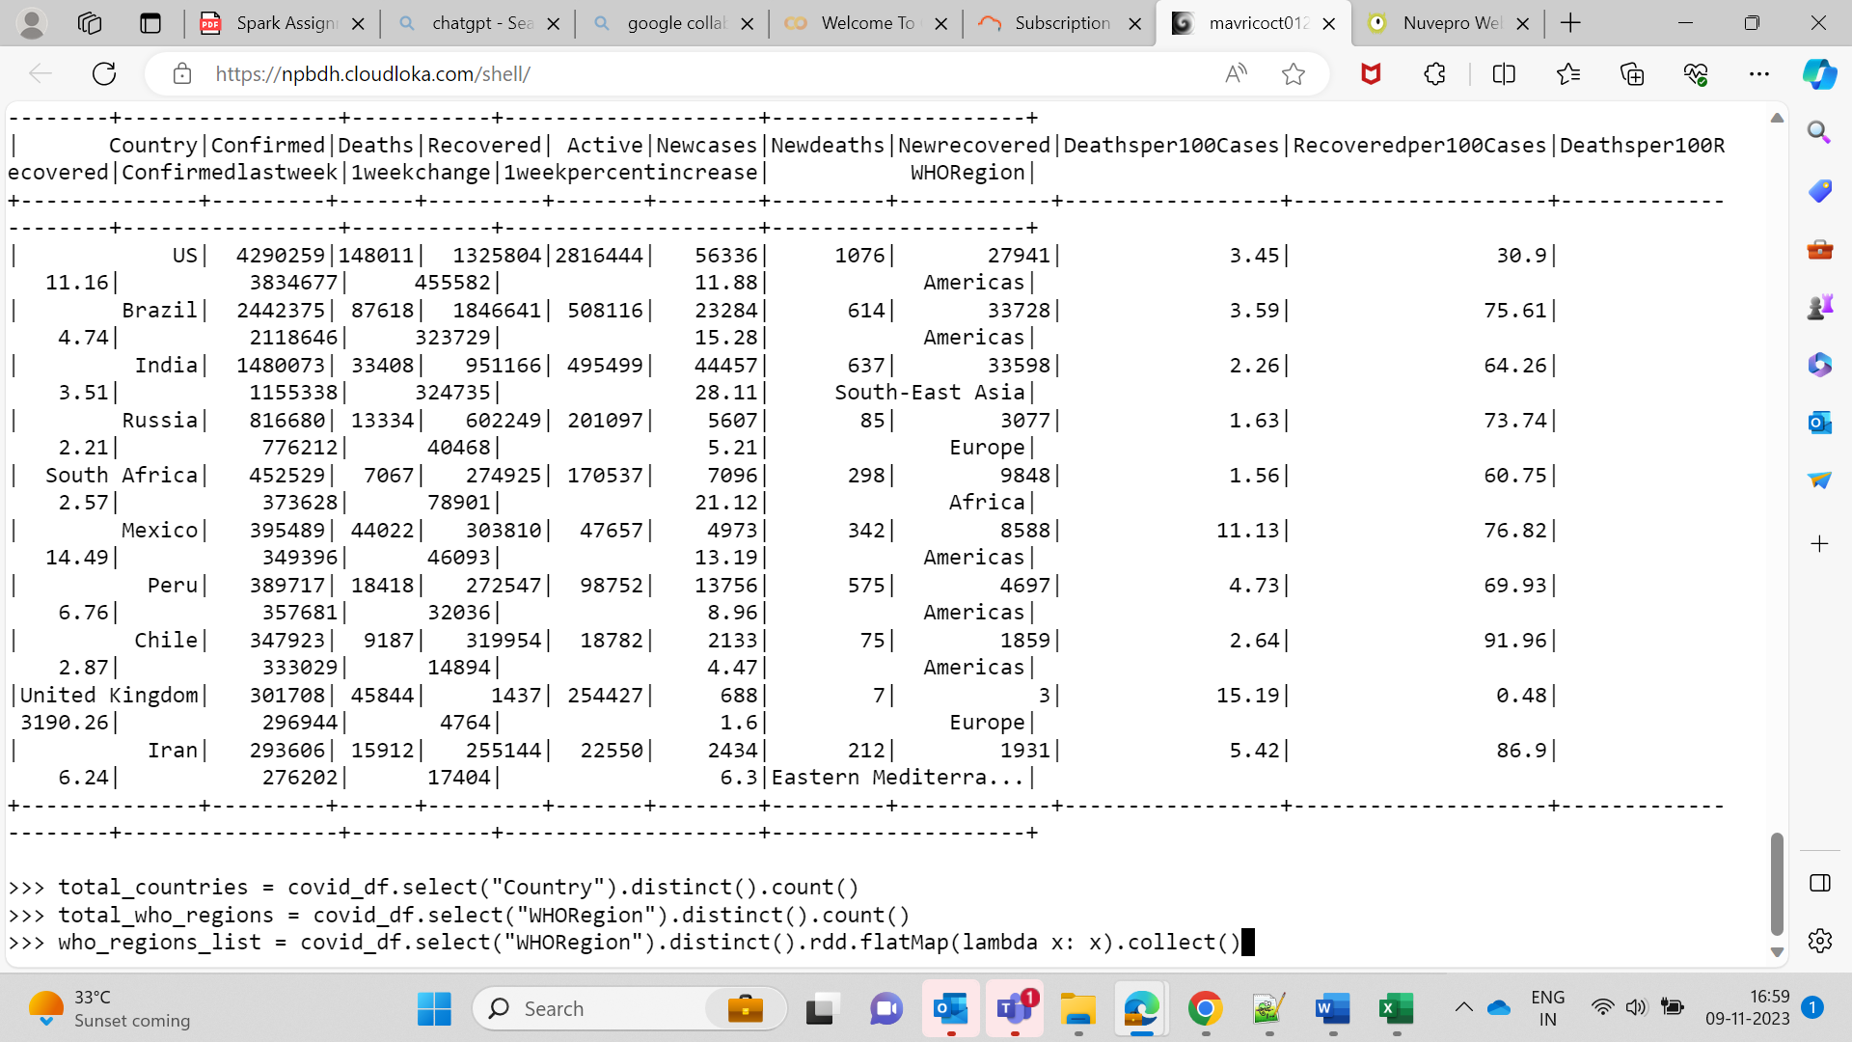

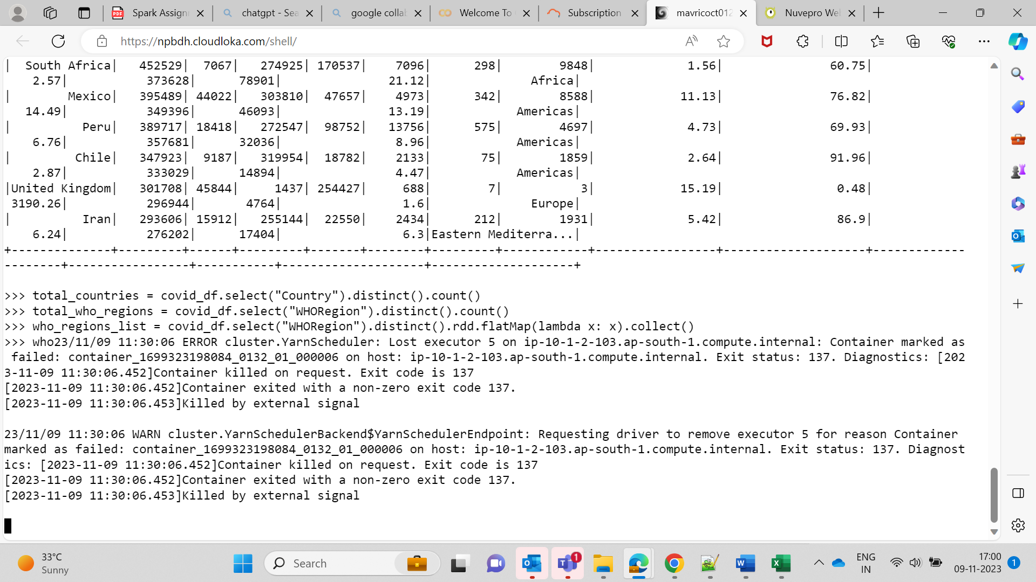  
  
  
Q4.  
Bottom 10 countries under the WHO region with COVID-19 confirmed cases

bottom_10_countries = covid_df.orderBy("Confirmed").limit(10)

bottom_10_countries.show()  
  
